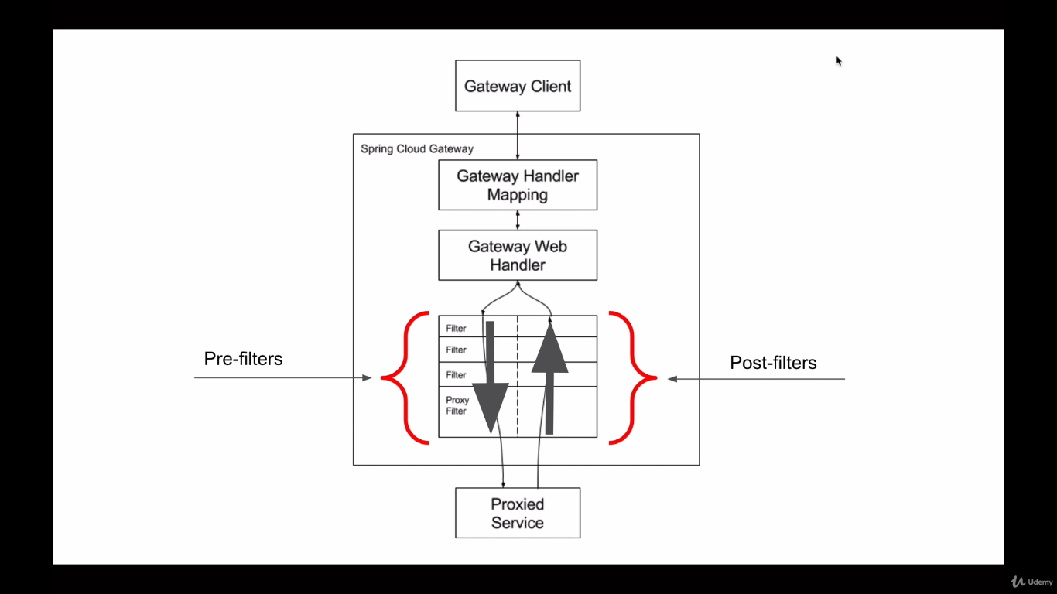

We will learn how to implement custom global gateway filters.

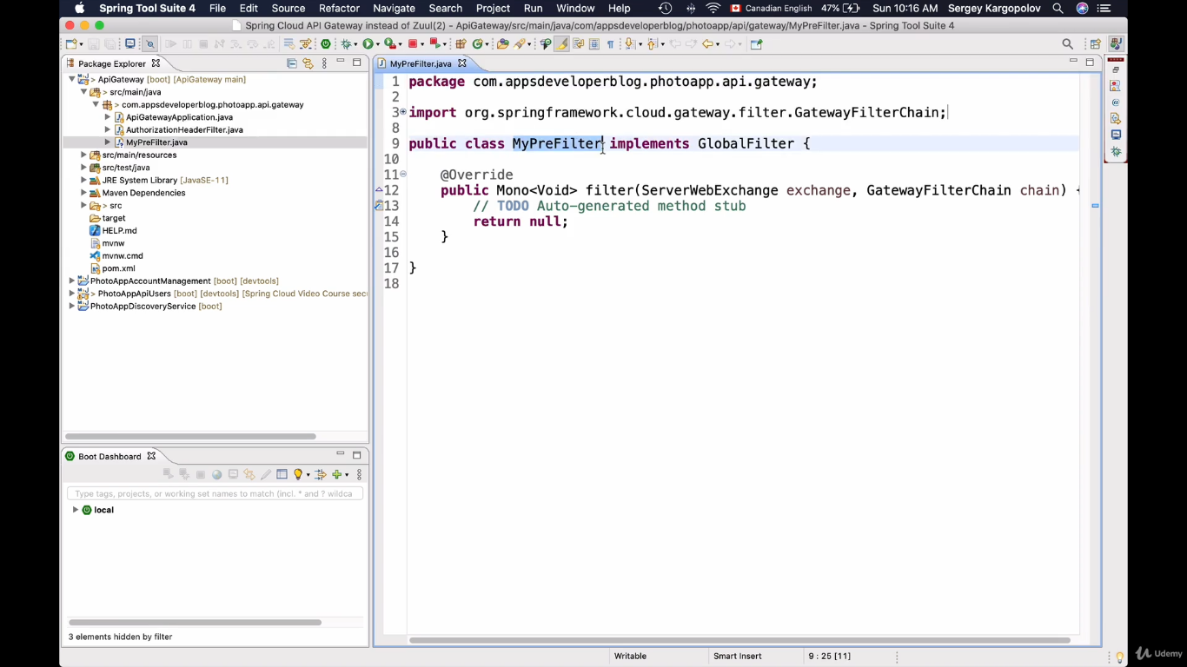

Spring cloud API gateway will automatically understands that which filter is pre-filter and which filter is post-filter based on the logic implementation.

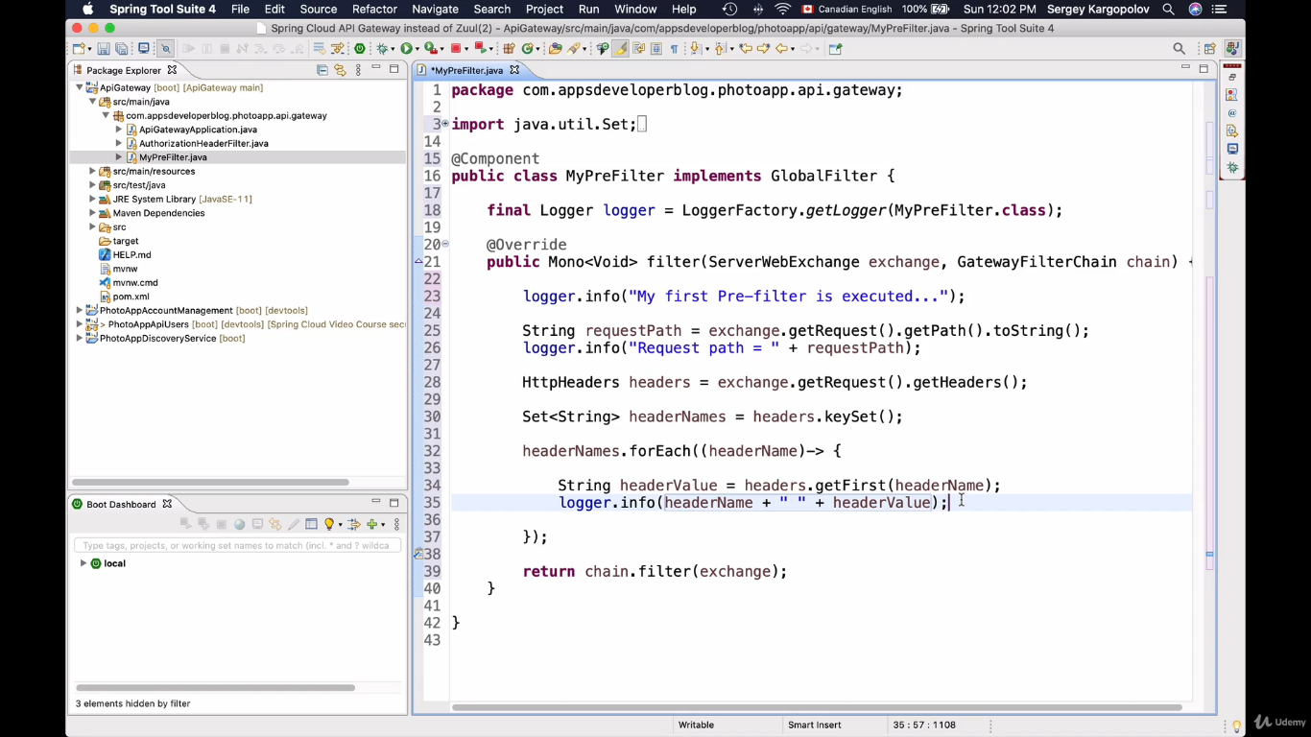

The above implementation will print the information of request.

Run the application with valid jwt token and check the console for log values.

**Custom gateway global post filter.**

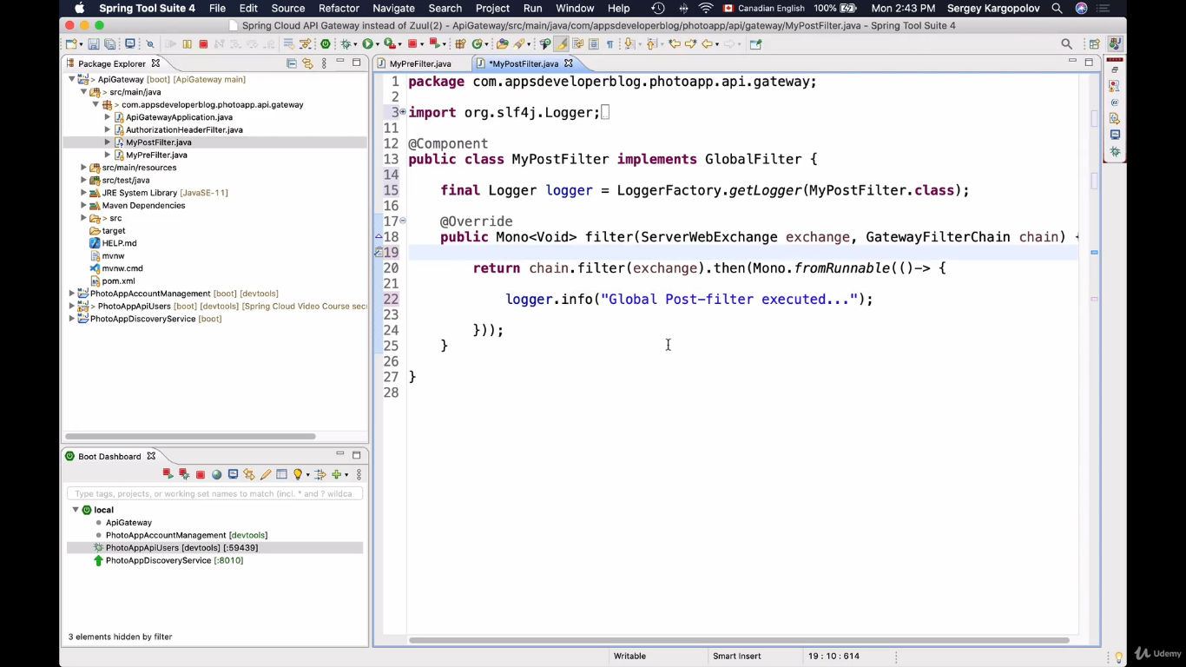**Basic implementation.**

**Configuring post and pre filter in a single class.**

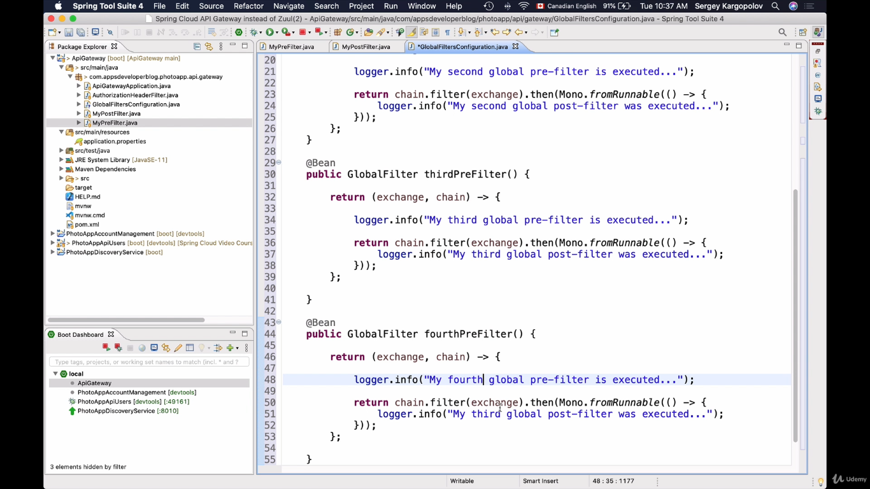

Ordering the filters

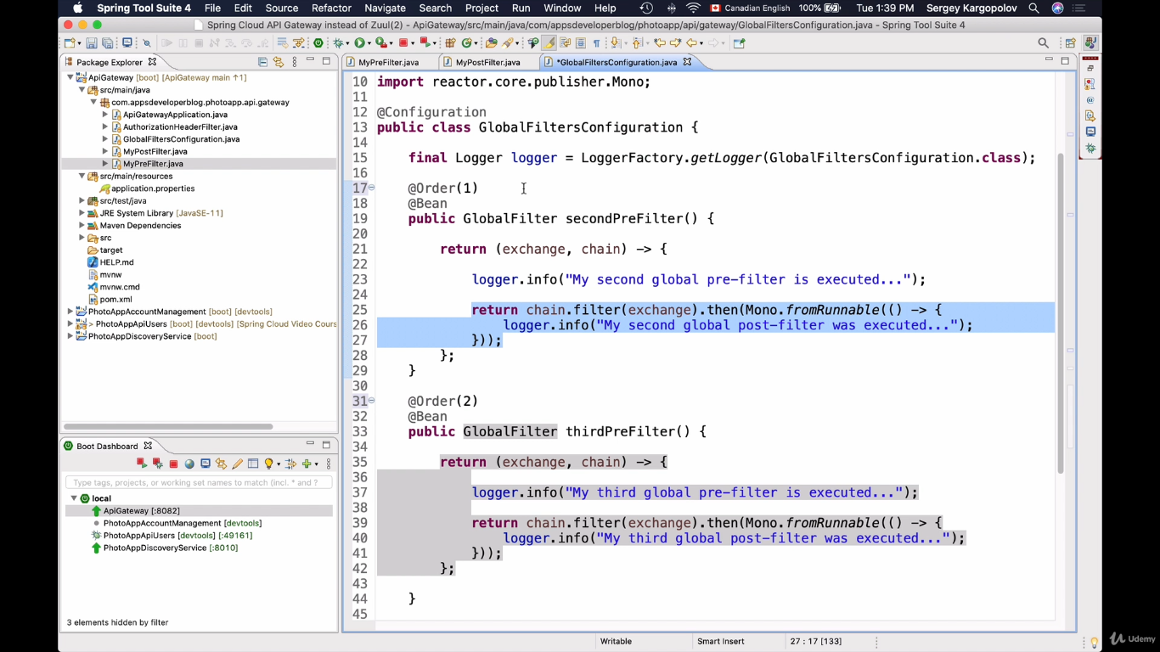

In pre-filter most lower value has higher priority, but in post- filter most higher value has higher priority.

Try to run and check the ordering